SELECT o.id_obat, nama_obat, id_transaksi_detail, id_transaksi

FROM obat as o

right join penjualan_detail as pd

on o.id_obat = pd.id_obat

WHERE pd.id_obat = 'M001'

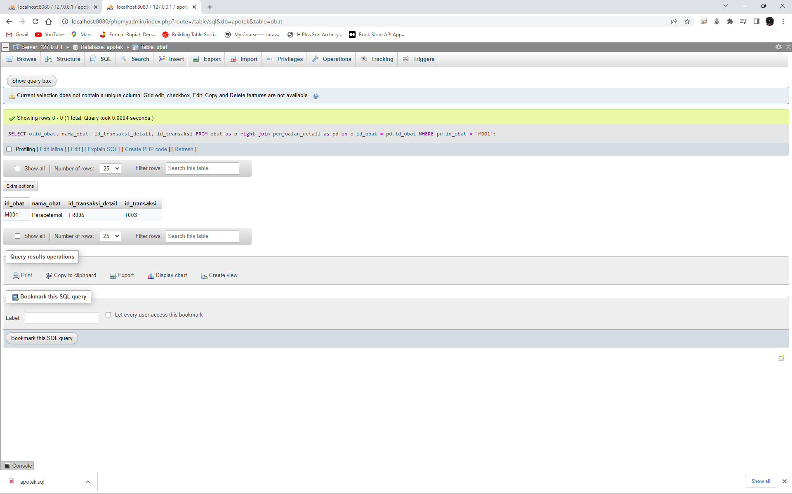

SELECT nama_pelanggan, total_transaksi

FROM pelanggan as p

join transaksi as t

on p.id_pelanggan = t.id_pelanggan

WHERE total_transaksi >= '500000'

